**CD and CART Defects, Fixes & Workarounds – April 3, 2020**

**Defects – Fixes, Current Issues & Workarounds**

Below is a list of current defects with how to work around the issues and which items will be fixed in an upcoming release. Please note that CD and CART updates are going to be made on a regular basis so issues not covered by the upcoming release, are still being worked and will be addressed as quickly as possible.

|  |  |  |  |  |
| --- | --- | --- | --- | --- |
|  | ***Defect*** | ***Symptom*** | ***Workaround*** | ***Status*** |
| Conservation Desktop | | | | | |
| 1. | Invalid Geometries in NPAD | * Import land unit and it goes to draft status; no edit gets the land unit to planned status * Import land unit and on save, the land unit disappears – land units do show in the land unit report tool | Wait until next day so script can fix the geometry issues.  If the land unit was imported many times, the user will need to edit out the pancaked draft land units. | Nightly script is being run until a permanent fix can be implemented. |
| 2. | Unable to Merge Land Units | * Merge button is clicked but the edit is not completed   + This issue seems to be associated with land units that have practices from old CSP contracts but may not be exclusive to that | None at this time. | Currently diagnosing the issue, please submit a ticket to ServiceNow so that all scenarios can be evaluated. |
| CART | | | | | |
| 1. | Zero Point Values in Assessment Results | * Values in the Assessment Results Page are all zeros. | In the Assessment Summary Page, Select Recalculate from the Action menu. | Resolved |
| * Values for individual Resource Concern are zero. * Roll up for a Resource Concern is Not Met when should be Met | Verify that the Resource Concern is valid for the land use/modifier on each land unit assessed for that resource concern.   * Remove the resource concern from land unit that has an invalid land use/modifier. **OR** * Use the Override feature on the invalid land unit/modifier |
| 2. | ***Large number of land units*** | | | |
| **Assessments** with a large number of land units fail to load on creation | * Recalculate process on creation of the assessment fails to complete – at 60 minutes an error is displayed | * Close CART if recalculate takes longer than 10 minutes. * Open CART and search for the assessment that was being created. User should be able to work on completing the assessment on the land units. A manual recalculate will need to be completed before Results will be accurate and before the assessment can be set to Ready for Ranking. | Continual improvements are being made to the services and stored procedures used in the recalculate process. Currently we have successfully tested assessments with 50 land units in production. Work to find the upper limit is in progress. |
| **Ranking Pools** not returning on larger assessments | * No Ranking Pools are returned when pools are working for similar smaller plans | None at this time | Currently investigating a potential time-out issue. |
| 3. | Ranking Pools not being returned | * No Ranking Pools are returned when pools are working for similar smaller plans | None at this time | Currently investigating a potential time-out issue. |
| * No Ranking Pools returned | * Occasionally the GeoPortal or other required services go down or time-out. Set the Assessment Status back to In Assessment then set the status back to Ready for Ranking (this will recalculate the assessment and reevaluate applicable pools) * May be a ranking pool geospatial data change – if one pool in the state has a geospatial issue, no pools are returned.   + If pools have worked in the past, verify there was not a new pool created causing the problem   + Check with Geospatial Data Configuration staff to make sure they have not changed data provisioned to CART that may be used in a pool * User may have set the assessment status to Ready for Ranking and then let several days or more pass before clicking Rank. Set the Assessment Status back to In Assessment then set the status back to Ready for Ranking (this will recalculate the assessment and reevaluate applicable pools) |  |
| 4. | Saving issues on the Resource Inventory page of Assessment | * User answers all the questions and marks the land units complete, on save an Internet Explorer Error occurs and when closed, the CART browser window refreshes and no changes were saved for the page. | Save frequently; save after each survey section and once the surveys are complete, before marking the land units complete. | Currently investigating a potential time-out issue. Most frequently happens when there are a large number of land units, a large number of resource concerns or a combination of the two. |
| * User saves and the save appears to complete, but answers are not saved. | Try again. | Investigating the issue |
| Geospatial | | | | | |
|  |  |  |  |  |

**Support and Resources**

CD and CART training and reference materials are available for State Points of Contact (POCs) and others. These resources include: User’s Guides, Lesson Plans, Video Recordings, Online Forums, and frequently asked questions (FAQs). CD and CART support questions from field users should be routed to their State POCs. If the State POC is not able to resolve the issue, they can elevate it to the Regional Support Cadre and then if needed to the Help Desk.

***CD/CART Help Button***

Clicking the Help button located on the CD or CART main toolbar will open online help in a separate browser window. Within CD, this opens the CD User’s Guide. In CART, Help will open the CART USDA Connect Site.

***CD POC SharePoint Site***

<https://usdagcc.sharepoint.com/sites/nrcs_programs/cptad/cd/SitePages/Home.aspx>

*What’s here?*

* CD lesson plans, PowerPoints, sample agendas & other training materials *(state POCs can post their materials here to share)*
* CD user’s guide, videos & other help documents
* Shared documents
* Discussion
* Teleconference recordings
* List of State POCs
* Suggest enhancements for CD or CCG
* Share or view what states are doing for CD training

Access: All users have access to view and download materials. State POCs can post to the site.

***CD USDA Connect Site***

<https://connections.usda.gov/wikis/home/wiki/Wbb237a288a28_4374_b11b_9ecf10b0c0bc>

*What’s here?*

* CD lesson plans & webinar recordings
* CD user’s guide
* Links to videos for selected user’s guide topics
* Emails sent from CD Coordinator
* Discussion forum

Access: All users have access to view or download materials, and to post on the discussion forum.

***CART USDA Connect Site***

<https://connections.usda.gov/communities/community/CARTHelp>

*What’s here?*

* CART lesson plans & webinar recordings
* CART reference materials

Access: All users have access to view or download materials and to post on the discussion forum.

***Support for Field Users***

Any questions should be routed to your state CD Point of Contact, if you are not sure who that is you can find a list [here](https://usdagcc.sharepoint.com/sites/nrcs_programs/CPTAD/CD/Lists/POC/AllItems.aspx).

***Support for State POCs***

***CD/CART Regional Support Cadre***

To assist you with supporting CD and CART, a CD/CART Regional Support Cadre has been established. Utilize these individuals as needed when experiencing software related CD and CART user issues. Procedural, policy and program questions should continue to flow through normal channels.

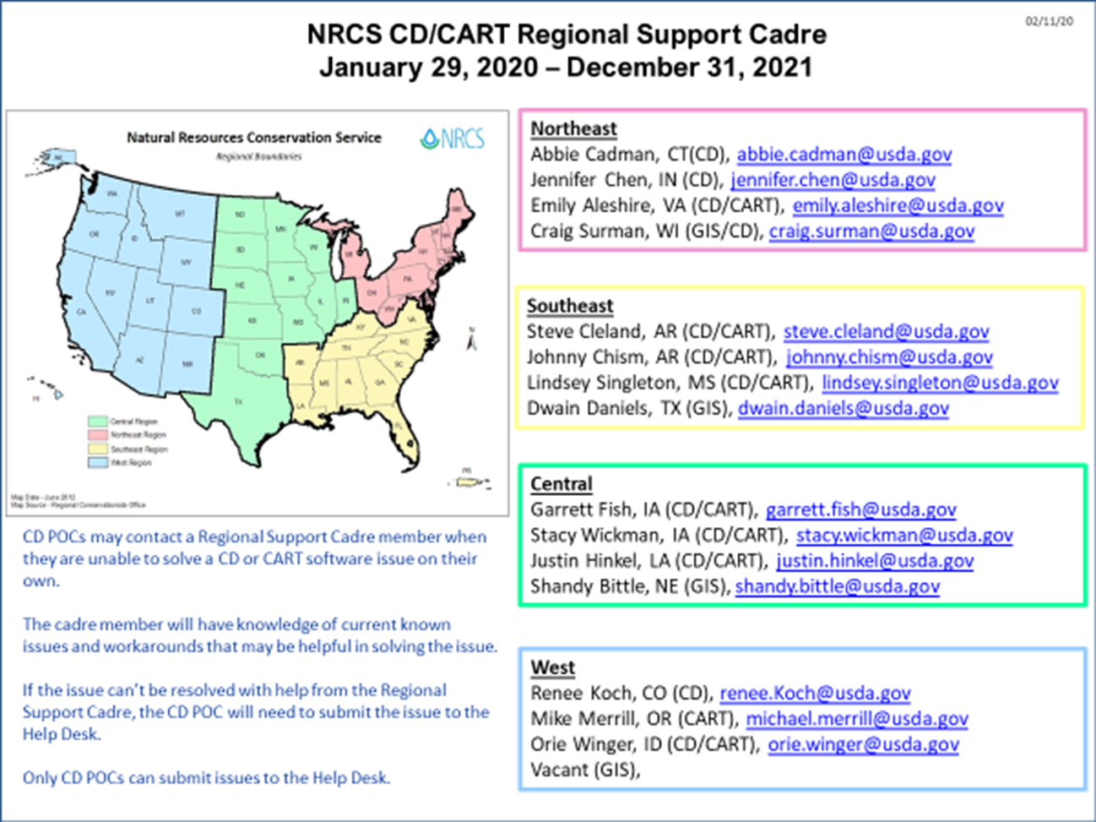

***CD/CART Help Desk Portal***

The Help Desk Portal can be opened by clicking the link at the lower right corner of CD or CART or using this [link](https://usdafpacbc.service-now.com/ServiceDesk/). Either option will open the FPAC Service Desk.

All Conservation Desktop issues should be routed through the State Point of Contact. State POCs can use the Help Desk Portal link to submit a new help desk ticket or check the status of a previously submitted ticket. The Help Desk verifies that tickets are submitted by a State POC or by the Services Integration and Modernization (SIM) Team. Tickets submitted by other users will be returned with instructions to route the issue through your state contact.

Submitted tickets are reviewed by a Tier 1 Help Desk Analyst. If needed, the issue is elevated to Tier 2 support. If the issue cannot be resolved by the Tier 2 Help Desk Analyst, it is elevated to the SET Team (Sustainability Engineering Team) and a developer will attempt to resolve the issue.

The CD Support Request must be filled out and submitted with each Help Desk ticket, the form can be downloaded [here](https://usdagcc.sharepoint.com/sites/nrcs_programs/CPTAD/CD/Conservation%20Desktop%20Help/Forms/AllItems.aspx).